Risky Business:
Invasive species management
on National Forests
by
George Wooten, Jr. & Marlene Renwyck
A review and summary of needed changes in current plans, policies and programs

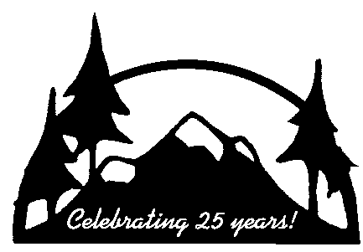

Kettle Range Conservation Group

February 2001
Risky Business: Invasive species management on National Forests

A review and summary of needed changes in current plans, policies and programs

February, 2001

By

George Wooten, Jr.
Botanist, KRCG
23 Aspen Lane
Winthrop, WA 98862
509-996-3835
gwooten@kettlerange.org
Marlene Renwyck
Botanist
1470 Channel Road
Lopez Island, WA 98261
360-468-3837
509-467-4029

Prepared for
Kettle Range Conservation Group
P.O. Box 150 35 W. Main, Suite 220
Republic, WA 99166 Spokane, WA 99201
509-775-2667 509-747-1663
http://www.wildwashington.org/krcg/
tcoleman@kettlerange.org

We graciously acknowledge the support provided in the preparation and publication of this report by:

The Kongsgaard-Goldman Foundation

The Bullitt Foundation

Opinions expressed in this report do not necessarily reflect the views of the supporting foundations.

Copies of this report can be found at:
http://www.kettlerange.org/weeds/

Or purchased from KRCG offices for $10

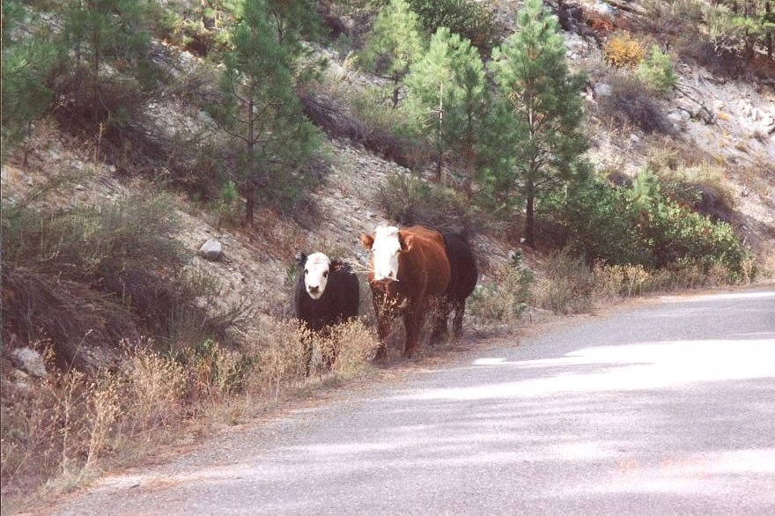 | 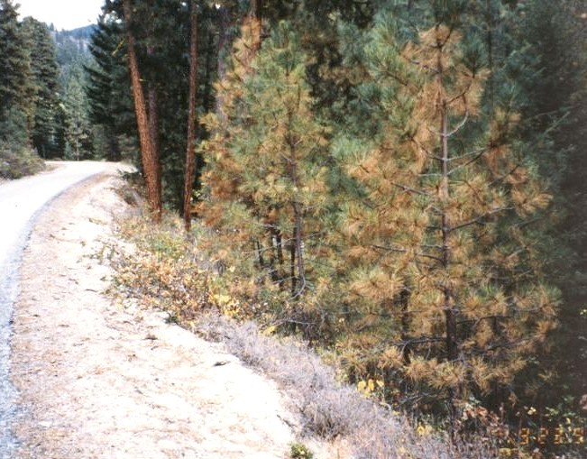
Photo 1. Cattle feeding on knapweed which survived herbicide treatment. Okanogan NF, WA. | Photo 2. Damaged and dying ponderosa pines and killed bitterbrush (foreground) following herbicide treatment. Okanogan NF, WA.
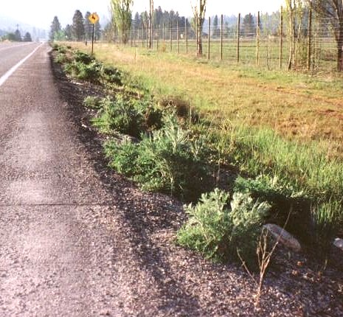 | 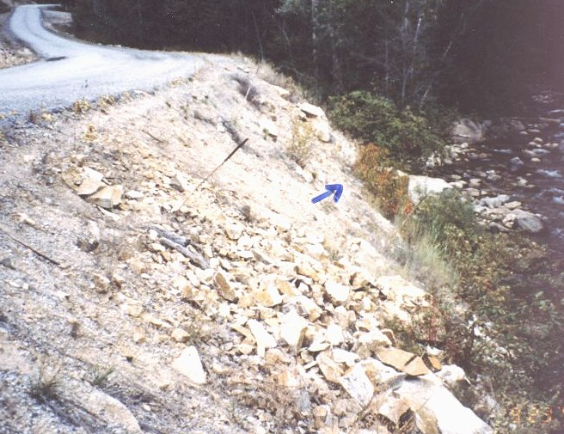
Photo 3. Herbicide-resistant knapweed along a heavily treated road. Okanogan County, WA. | Photo 4. Eroding river banks with sparse cover of native plants killed or damaged (arrow) by spraying herbicide at stream. Sparse weeds on site (foreground) survived. Okanogan NF, WA.`

Table of Contents

Executive Summary 5

Introduction 10

Chapter 1. Policies 13
A. Policies and plans need clearly defined goals and objectives linked to performance measures.
B. Projects and plans must incorporate measurable standards and guidelines.
C. Programs must be held accountable to budgets.
D. Policies, plans, and programs need adjustments based on periodic evaluations.

Chapter 2. Disclosure 37
A. Planning documents must disclose all potential significant impacts.
B. Projects must have goals that accomplish a stated need.
C. All planning documents must address the impacts of invasive species.
D. Decisions must be subject to public review and appeal.

Chapter 3. Adverse impacts 67
A. Adverse impacts of chemicals on human health.
B. Adverse impacts of chemicals on the environment.
C. Stringent safety precautions for handling chemicals should be followed.
D. Treatments should receive adequate public notification.

Chapter 4. Monitoring and reporting 98
A. Monitoring should be included in all projects with invasive species impacts.
B. Monitoring procedures.
C. Mitigation procedures must include implementation monitoring.

Chapter 5. Prevention of weed invasions 109
A. Preventive measures must receive high priority.
B. Plans need comprehensive strategies.

Chapter 6. Education and research 114

Acronyms 116

References 118

Appendix A. Management strategies and paradigms 133

Appendix B. Chemical safety considerations 140

Abstract

Invasive species management on public lands is a complex issue which is currently being approached in a variety of ways. Recent efforts to eradicate weeds on National Forests have been costly and sometimes ineffective. Controversy has erupted over the use of herbicides and their potential for harm to health and the environment. This study critically examines the basis of current plans, policies and programs for managing invasive species on federal public lands, along with a presentation of alternative solutions.

To successfully control invasive species, sound policies must be in place, which require clearly stated, measurable goals and objectives based on an understanding of the biology and ecology of invading species. In responding to invasions on public lands, managers need to shift their approach from short-term reduction efforts to flexible approaches that treat the causes of invasions rather than the symptoms, while placing more emphasis on prevention and monitoring.

Executive Summary

Invasions by alien plant species remain one of the most serious threats to the long-term conservation of resources and biological diversity (Johnson et al., 1994, Clary and Medin, 1990). Despite efforts by federal, state and local organizations to combat the spread of invasive species, epidemics on federal lands continue at high rates.

As of 1997, over 860 exotic plant species had invaded arid and semi-arid portions of the Pacific Northwest (Hann et al., 1997). Actions taken by federal land management agencies have sometimes been ineffective, inappropriate, and lacking in accountability, with the result that an endless cycle of invasion, treatment and

re-invasion is perpetuated (Figure 1). Studies have shown that severe costs and even degradation of natural resources have resulted from inappropriate actions in relation to invasive species (Cottam and Stewart, 1940).

This study critically examines the basis of current policies, plans and programs for managing invasive species, along with a consideration of viable alternatives. Discussion topics are divided into chapters and sections in the main document, followed by operating principles and recommended solutions at the end of each section. Throughout the main document, case examples are taken from current Forest Service programs to illustrate specific points.

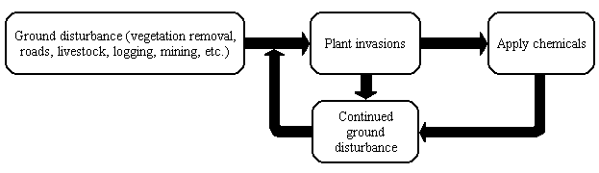

Figure 1. The cycle of plant invasions perpetuated by continued disturbances.

Policies

To be effective, policies and plans should have clearly stated measurable goals and objectives based on an understanding of the biology and ecology of invading species. Sound policy regarding invasive species should be consistent throughout the National Forest system and should guide both program and project planning. All levels of invasive species management should operate within a decision-making framework that manages the processes and causes of invasions, not mere symptoms. Higher priorities should be placed on the prevention of new introductions and stopping the further spread of established invaders (Campbell, 1993).

Performance measures should be included in planning and program development to insure accountability, both in terms of effectiveness as well as cost. Measurable standards and guidelines should be part of all invasive species programs in order to determine if program objectives are being accomplished. These standards should include determination of damage and action thresholds for both invasive species as well as treatments.

Program budgets should include line items for required monitoring and mitigation measures. Funding for projects, such as invasive species eradication, should be contingent on the production of satisfactory evaluation reports. Programs and plans should be periodically adjusted based on evaluation and accomplishment reports which include the
results of monitoring.

In addition, a framework for program operations should be considered that incorporates principles of ecosystem management, true Integrated Pest Management, precautionary principles, adaptive management and interagency coordination (presented in Appendix A).

Disclosure

Projects which manage invasive species must begin with a stated purpose and need from which goals and objectives of the project follow. Planning documents must disclose all potential and known impacts as well as provide detailed discussion and mitigation measures for all reasonably foreseeable impacts. Greater emphasis must be placed on these requirements than in the past, particularly for chemical treatments, cumulative and indirect effects and non-target environmental effects.

Planning documents should provide site- and species-specific analyses in order to make proper decisions about each situation. Information presented must encompass the range of potential outcomes, both pro and con. Planning analyses should include up-to-date, relevant, and peer-reviewed information and should be impartially prepared and reviewed by qualified personnel with expertise and training in holistic invasive species management. Projects should have adequate baseline environmental information prior to implementation in addition to plans and adequate funding for the monitoring and evaluation of effects and procedures.

Because of their known, unknown, and potentially adverse impacts, herbicide treatments should be considered only as a last resort with consideration given first to all other viable alternatives. In addition, the decision to use herbicides on public lands necessitates the demonstration of an overwhelming public need that takes into account and discloses environmental impacts. Planning documents should provide an analysis of the long-term effectiveness and environmental effects of both chemical and non-chemical alternatives as well as required mitigation measures for unavoidable impacts.

All projects on public lands which involve soil disturbance should include an analysis of project effects on the spread of invasive species. Decisions regarding the management of invasive species should remain open to public review, comment and appeal.

Impacts

Measures to protect public health and the environment must be in place prior to implementation of an invasive species management program. If using an Integrated Pest Management approach, the impacts of chemicals on human health and the environment
must be eliminated or minimized.

Planning documents should provide detailed descriptions of the environmental fate of all applied chemicals along with expected human and animal exposure routes including inhalation, which may result from their use. Safety and damage thresholds for allowable concentrations and movement of chemicals should be expressly given in the planning document. Documents should specifically disclose the effects of chemicals on vulnerable groups including children, fetuses, the elderly, those with impaired nervous, respiratory or immune systems and sensitive individuals.

Herbicides should be avoided in situations where they are likely to increase the chance of acute effects, human cancer, immune system effects, endocrine system effects, behavioral effects, synergistic effects or cumulative effects. Herbicides containing undisclosed or “inert” ingredients should not be used at all on public lands.

The handling of chemicals should follow strict precautions including label directions and other procedures. The public and all employees should be notified through a variety of local outlets whenever any chemical applications occur on public lands and chemically treated areas should be posted for at least one year. Herbicides should be avoided in areas where controlled burns are expected and firefighters should be warned when working in areas recently treated with herbicides. Reported herbicide exposures must be tracked on confidential incident-tracking forms, which are shared with the state health and labor departments.

Successful invasive species programs must function effectively without compromising the health of soil, water and native species. The use of herbicides can result in a loss of biological diversity and ecosystem integrity (Randall, 1996; Rosentreter, 1994), destruction of wildlife habitat and wildlife populations (Connor and McMillan, 1990), alteration of soil microclimates (Evans and Young, 1984), and degradation of water quality (Rashin and Graber, 1993). Through vegetation removal, herbicides can also increase sediment yields (Lacey et al., 1989) and impact wildlife habitat (MacKinnon and Freedman, 1993). Monocultures of invasive species, such as cheatgrass, can also increase fire frequency and severity (Young and Evans, 1978).

The disclosure of environmental impacts needs to include a reasoned, unbiased analysis of environmental costs and benefits. All adverse effects on wildlife and the environment including those from cumulative, indirect and non-target effects, must be eliminated or else minimized and mitigated. Herbicides should be avoided in situations where they will negatively impact soils, aquatic habitats, native species, TES species, wildlife, or where they will increase the development of herbicide-resistant weed species. Whenever possible, the use of herbicides should be avoided through programs that prioritize the prevention of the causes of invasions.

Monitoring

Accountability for actions taken by federal land managers is an important responsibility that is seldom fully realized. Without clearly defined goals to guide actions, managers have no measurable objectives to assess the effectiveness or appropriateness of the actions they take. Assurances must be made that actions will be accounted for in regular monitoring programs and periodic evaluations.

Monitoring should include three critical components during invasive species management projects:
- measurement of the extent of invasive species populations;
- measurement of the effectiveness of treatments; and
- measurement of non-target effects, e.g., incident tracking and measurement of environmental consequences on non-target ecosystems from chemical treatments.

Monitoring methods should use controlled studies, valid statistical methods, quantitative measurements, reproducible methods, replicate sampling, and consistent recording procedures. In addition, monitoring should be performed by qualified personnel using map-based systems for locating invasive species and written records that are maintained for future use in permanent files.
Baseline monitoring of the extent of invasive species populations and land condition should occur prior to project implementation and as a regular part of Forest's annual monitoring schedules. With regards to weed management programs, monitoring should also occur during project benchmarks. For instance, during implementation the parameters for environmental fate, e.g., drift and leaching, should be measured. Following implementation, the effectiveness of the treatment should be measured in addition to changes in the extent of invasive species or changes to the non-target environment. Consideration should be given to results both from and despite the treatment.

Three types of monitoring should be considered in public land management:
- Effectiveness (including measurements of both action and damage thresholds for treatments as well as invasive species),
- Implementation (whether or not the project occurred and how) and
- Validation (tests of whether or not initial assumptions about the methods were correct).

Monitoring should be included in all projects with invasive species impacts, not just “weed” management projects. In addition, mitigation measures should also be subject to evaluation monitoring. Results should be periodically summarized and sent to regional and national offices in a timely fashion, as well as be available to all agency employees and the public.

Prevention

Scientists and federal agencies are aware that prevention and early detection is the least expensive and most effective way to manage plant invasions. A higher priority should be given to prevention than what currently exists within the Forest Service, while at the same time recognizing the true meaning of such a concept.

Prevention implies an impediment, hindrance, or preclusion. Compared to reduction, which implies a lessening or decline, or mitigation, which implies relief or alleviation; prevention calls for a barrier to that which causes invasive species to spread. To date, the focus of the Forest Service with respect to invasive species management has been on reduction and mitigation, not prevention.

Prevention measures to control the spread of weeds should be incorporated into all public land management activities. Map based inventories should be maintained, kept up to date and coordinated within and between agencies. Prevention efforts should be guided by a desirable future condition, which takes into account ecosystem health and integrity. A list of specific prevention measures is provided in Appendix A.

Education and research

Invasive species management requires a long-term commitment to education as well as increased awareness of the nature and extent of the problem and its control. Signs, brochures, posters and news articles should all be used to communicate the problem to the public and government workers. Workshops and classes should be held that would bring interested people together in informative, problem-solving formats. Plant identification workshops should be given for all field workers. In addition, more information should be provided about the potential harmful effects of herbicide formulations.

There is an overwhelming need for more data on the ecology and biology of plant invasions on public lands, including comparative studies on the effectiveness of various control strategies. Agencies and educational institutions need to invest in research on methods that could potentially help solve the problems of invading species such as developing more effective prevention strategies and less harmful control techniques. More studies are also needed on affected ecosystems, particularly for at-risk components such as riparian areas.

Research funding is an important component of invasive species management that should also be given consideration. Funding can occur through many types of cooperative agreements, including cost-sharing, regional laboratories, contracts and work-in-kind grants. Data sharing can occur through reporting, meetings, symposia, publication in the press, scientific literature and the internet.
Conclusion

In conclusion, federal public land management agencies would do well to implement invasive
species policies and programs which are more accountable for the causes of plant invasions, which fully evaluate and disclose the impacts of invasive species and treatment methods and which successfully begin to slow the spread of invasive species on public lands without compromising the quality of the environment or human health.

Introduction and Background

Plant invasions remain one of the most serious threats to the long-term maintenance of regional biodiversity (Johnson et al., 1994; Clary and Medin, 1990). In the United States, non-native species are suspected of being the highest cause after habitat loss for the listing of all threatened and endangered species (Flather et al., 1994; Wilcove et al., 1998).

Used in this report, invasive species refer to those plant species which are rapidly increasing in an ecosystem without controls on their population growth. The generic term “weeds” is used more loosely for any “undesirable” plants, or “unwanted” vegetation. Invasive plant species may also be referred to here as “noxious weeds” in the legal sense, as species designated for control. The terms “non-indigenous”, “exotic”, or “alien” plants are also used occasionally for species originating outside the area of invasion.

Noxious weeds are spreading on BLM lands at over 2,300 acres per day and on all western public lands at approximately 4,600 acres per day (BLM, 1996). As of 1997, throughout the Pacific Northwest, over 860 exotic plant species have invaded arid and semi-arid lands (Hann et al., 1997). Despite efforts by federal, state, and local activities to combat the spread of invading species, weed epidemics on federal lands continue at alarming rates. Land management agencies are failing to control biological invasions (Bureau of Land Management, 1996) and actions taken by federal management agencies have been ineffective, inappropriate, and lacking in accountability.

Studies in 1940 showed that severe costs, degradation and even destruction of resources have resulted from policies of both non-action and inappropriate action (Cottam and Stewart, 1940). Sixty years later, we continue to deal with the same consequences on increasingly larger areas with invading species. A synopsis of recent conflicts over the management of invasive species on National Forests in the Pacific Northwest is provided in Table 1, below.

Table 1. History of U.S. Forest Service policy with regard to noxious weeds. (Source: Journal of Pesticide Reform. 1992. Beyond Herbicide Wars: Trees, Weeds, and the U.S. Forest Service in the Pacific Northwest. Vol. 12, No. 2 (A publication of Northwest Citizens for Alternatives to Pesticides).

March 1984 | Northwest Citizens Against Pesticides, Oregon Environmental Council, and Portland Audubon Society win a sweeping legal victory (NCAP v. Block) that stops all herbicide programs on federal forestlands (Region 6 Forest Service and Bureau of Land Management) in Oregon and Washington. Judge James Burns retains jurisdiction in the case, meaning he must approve any EIS written to comply with the law. Soon thereafter, the Forest Service voluntarily curtails all aerial herbicide spraying nationwide on its forestlands.
June 1986 | Forest Service decides to ignore its inadequate 1981 Environmental Impact Statement (EIS) and rewrite its entire policy. Over the next 2½ years, many groups and citizens provided extensive input to the development of the new forest vegetation management policy.
December 1988 | Northwest Regional Forester James Torrence signs the Record of Decision for the Final EIS, Managing Competing and Unwanted Vegetation. This program sets the vegetation management policy in Oregon and Washington; all site-specific programs proposed in the Northwest will tier to this regional policy. Any proposed action in Region 6 that has the potential for vegetation management activity must comply with the new EIS after this date, including all timber sales.
January 1989 | Forest Service petitions the court to lift the spray injunction. The petition is opposed by NCAP. Judge Burns orders the parties (plus Coast Range resident Paul Merrell) to attempt a mediated settlement. Unresolved issues focus on implementation procedures and specific points of fact that were never addressed in the final EIS.
May 1989 | All parties to the suit sign a mediated agreement that specifies steps the Forest Service will take in implementing the regional policy. The Forest Service agrees to produce a regional guide for implementing the EIS within six months that includes profiles on 13 herbicides. The court-imposed spray injunction is lifted. Nine other parties file administrative appeals challenging the Regional Forester’s decision to adopt the programmatic EIS. The agency issues its own administrative stay on all herbicide use pending agency review of the appeals.
February 1990 | Forest Service issues its “Guide to Conducting Vegetation Management Projects in the Pacific Northwest Region”, a document required by the mediated agreement.
June 1990 | Forest Service dismisses all administrative appeals and lifts its administrative stay on herbicide use.
January 1992 | Forest Service issues the first herbicide profile for glyphosate, clearing the way for its use in northwest forests. Thirteen profiles are required by the mediated agreement.

Many of the problems wrought by invasive plant species are a symptom of a larger problem of poor health of the land, brought about by excessive soil disturbance, overgrazing and excessive roads (Belsky and Gelbard, 2000). Models of the spread of invading species resemble that of infectious diseases. For an ecosystem, invading species are the equivalent of disease agents (Mack et al., 2000; Vale, 1982; Hengeveld, 1989; Grime, 1977). Consideration of disease etiology has strong implications for invasive species management, particularly in addressing causes and prevention.

To be effective, policies should be based on an understanding of the biology and ecology of invading species and must place higher priorities on prevention of new introductions and stopping the further spread of invaders (Campbell, 1993). Policies should account for the causes of plant invasions and should take a hard look at curtailing nonessential activities that contribute to invasions.

Successful invasive species management programs must function effectively without compromising the health of soil, water and native species. Policies must be based on sound science and programs must adhere to policy guidelines. Planning documents should provide reasoned analyses of environmental costs and benefits. In the absence of a distinct program aimed at preventing noxious weed spread, inappropriate management may increase the spread of noxious weeds (O’Brien, 1997).

Accountability continues to plague federal land management. The General Accounting Office (2000) recently cited the lack of clearly stated goals and objectives as a significant obstacle for the Forest Service:

In addition, the Congress could help to expedite the Forest Service becoming more accountable for its performance by requiring the Agency to replace 13 years of promises and false starts with a strategy that includes clear goals and objectives, firm deadlines, and measurable indicators of progress.

Without clearly defined and mandatory objectives to force accountability, federal land managers have no means to assess the effectiveness or appropriateness of the actions they take. When policies provide sufficient direction for programs to operate under, assurances must be given that policy guidelines and regulations will be followed.

This study critically examines the basis of current policies, plans and programs for managing invasive species, along with a presentation of viable alternatives. Policy-makers should consider the formulation of a set of rules to guide invasive species management based on some of these principles.

Discussion topics are divided into chapters and sections in the main document, followed by operating principles and recommended solutions at the end of each section. Throughout the main document, case examples are taken from current programs to illustrate specific points.

